Step 1: Field operation

1. Preparation and Setup

Unboxing and Assembly:
- Open the main drone box and insert the landing gear securely.
- Carefully remove the drone from the box to avoid damaging the wings.
- Place the drone on a flat, level surface to ensure stability.

Installing Components:
- Attach the L2 sensor carefully.
- Insert one fully charged pair of batteries into the drone.
- Unfold the drone wings.

RTK Setup:
- While preparing the drone, set up the Real-Time Kinematic (RTK) system simultaneously.
- Mount the RTK unit onto its stand, check its battery level, and power it on.

2. Device Initialization and Pre-flight Checks

Power On Sequence:
1. Turn on the drone.
2. Turn on the Remote Controller (RC).
3. Ensure all three devices (drone, RC, and RTK) are connected and showing “RTK Signal: Normal.”

Pre-flight Configuration:
- Ensure all obstacle avoidance sensors are enabled.
- Upload the pre-planned flight path.
- Limit the flight distance to 1.5 km – 2.0 km.
- Set the maximum altitude to 150 meters.
- Ensure no individuals or objects are within a 5-meter radius of the drone before take-off.

3. Flight Operation

Flight Duration:
- Design each mission to last no more than 22 minutes to ensure battery safety and performance.
- If the flight extends beyond 22 minutes, initiate Return to Home (RTH) when the battery level drops to 30–35%, depending on the drone’s distance.

Battery Management:
- During battery replacement, ensure at least one pair of batteries remains inside the drone to prevent it from shutting down.
- Resume the flight from the break point after battery change.

Obstacle and Safety Monitoring:
- If an obstacle is detected during flight, the drone will pause automatically.
- In such cases, switch the flight mode to Manual, adjust the height or position manually, and then resume the mission using the Resume Flight function.

Environmental Monitoring:
- Continuously monitor drone telemetry and wind conditions.
- If wind speed exceeds 37 m/s, the RC will issue a warning.
- Immediately recall the drone and wait until conditions normalize.
- Only fly in open spaces, free of tall trees, buildings, towers, or bird activity.

4. Post-Flight Procedures

Shutdown and Packing:
1. Turn off the drone.
2. Power down the RTK system.
3. Detach the L2 sensor.
4. Carefully remove all batteries.
5. Fold the drone wings and pack it back into the box.
6. Detach the landing gear and close the drone box securely.

5. Safety and Responsibility Notes
- Ensure all team members are briefed on safety protocols.
- Maintain visual line-of-sight with the drone at all times.
- Keep emergency landing zones pre-identified.
- Always check weather conditions before deployment.

Step 2: Drone data processing

Raw Image Processing
# Before starting the processing, create a folder named after the grid number you are working on (e.g., Grid_101). Inside this folder, there must be seven subfolders. The subfolders should be named as follows:
- DEM
- Intermediate
- Lidar_3D
- Ortho_2D
- Photos
- Raw_data
- Terra

First, put the raw file folders of each grid inside the “Raw_data” folder. Now you may begin your journey!

- Initial processing in “Terra”
To process Lidar data using DJI Terra you have to have a license which needs to be activated in your pc and this license can be activated in only one pc. So, you have to sign into Terra using a gmail and id password. If you have signed in to DJI Terra there will be a folder named “DJI” created in the “Documents” folder of the pc. Inside the DJI folder there will be a folder named as the gmail you have used for sign in. The new missions created under DJI Terra software for 2D/3D processing will be automatically saved inside this folder.

- Open DJI Terra. Click “New Mission”. Choose “Visible Light” for 2D processing and “Lidar Point Cloud” for 3D processing.
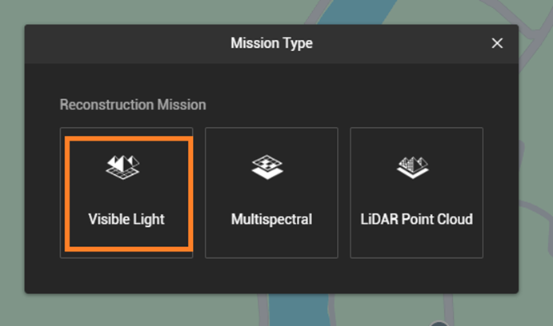
- If you chose Visible light then write mission name according to your preference (i.e. Grid_101_2D). Click on the folder sign named “Add folder” (can see the name while hovering the mouse over the folder sign) under the “Photos” section. Add your desired grid’s from “Raw_data” folder.
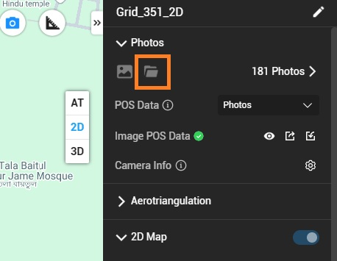

- After the raw image folders being added select “2D map” under Parameters section. Then click on “start reconstruction”.
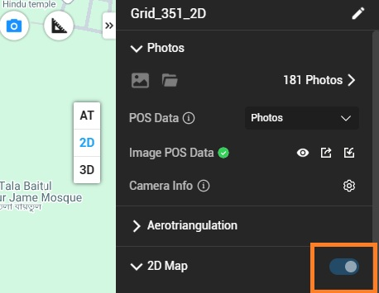

- After selecting parameters on the right panel processing progress appears on the left panel.
- When the processing is done click “Export” on the processed mission and save the zip file in the “Terra” folder.
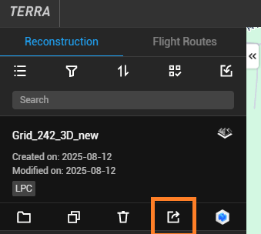
- Now go to the Documents -> DJI -> DJI Terra -> gmail name folder (i.e. nsusurfit@gmail.com) -> Grid_101_2D -> map -> copy the following files
result.prj, result.tfw, result.tif
- Paste the copied files into the previously created “Ortho_2D” folder of the same grid and rename them as “Grid_101_2D”.
- Then, go back to Step 1. Choose “Lidar Point Cloud” for 3D processing and name the mission (e.g., Grid_101_3D).

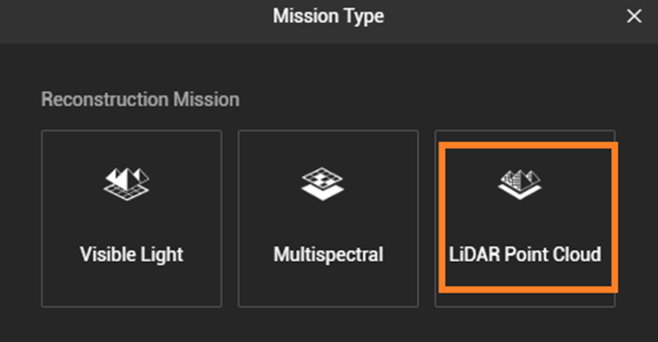
- Click “Select Folder” under the “Files” section and add the desired grid’s “Raw_data” folders.
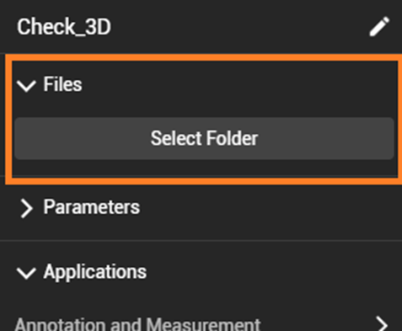
- After adding the raw image folders, select “Ground Point Classification,” “DEM,” and “Contour” under the Parameters section.
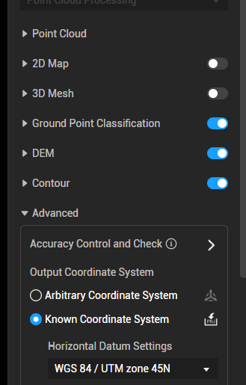
- Check the UTM zone under the Advanced section and ensure it’s set to “WGS 84 / UTM zone 45.”
- Finally, click “Start Reconstruction.”
- After the processing is done click “Export” on the processed mission and save the zip file in the “Terra” folder.
- Then again go to the Documents -> DJI -> DJI Terra -> gmail name folder (i.e. nsusurfit@gmail.com) ->Grid_101_3D -> lidars -> terra las -> copy the las files and paste onto the previously created “Lidar_3D” folder of the same grid.

- Point cloud processing in “Cloud Compare”
- Open Cloud Compare.
- Click on “File” -> open a las file from the Lidar_3D folder.
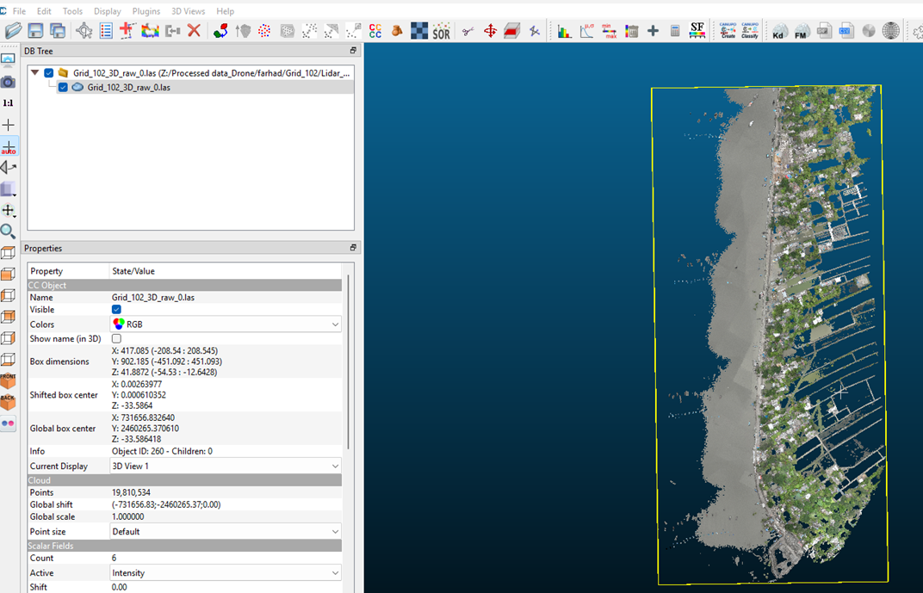
- Click “Apply All” and then “Yes to All” in the floating window. A LAS (3D) file will open. Use left-click to move the image in the Z dimension and right-click to move it left-right or up-down.
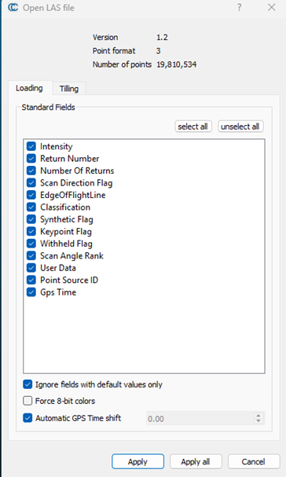
- Click the cloud name at the top left, and a yellow rectangular box will appear around the image.
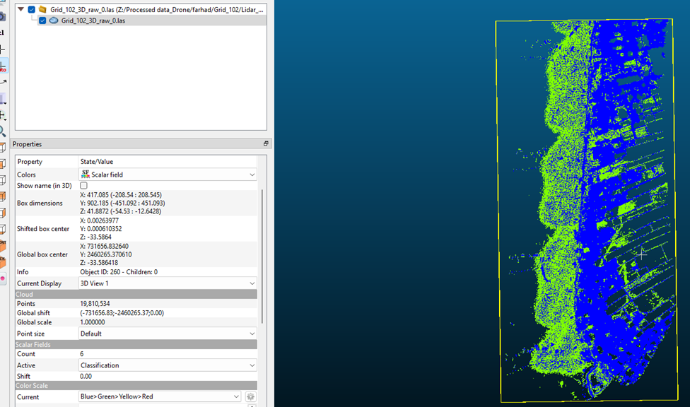
- In the properties, select “Scalar Field” under the Colors section, then choose “Classification” under Scalar Fields. The image will change color to green and blue, depending on the scale set to “Blue > Green > Yellow > Red.”
- Locate the Min/Max icon at the top of the screen. Click it to open the "Filter by Value" window. Set the range to 1–1.5, then click "Split."
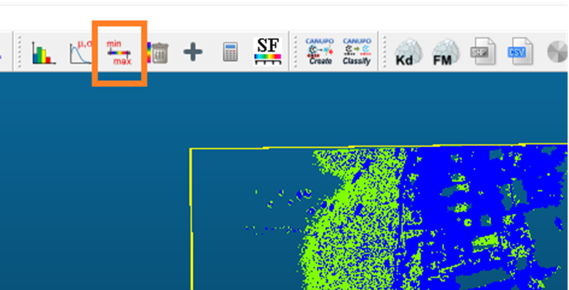
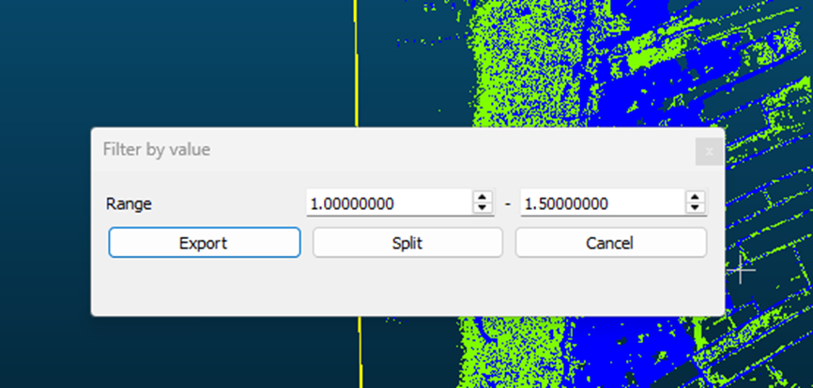
- The split action creates two new files: one containing the higher elevation points of the 3D cloud image and the other containing the lower elevation points.
- Change the color of the newly created LAS files to “RGB” to easily distinguish between the high and low points by toggling them on and off.
- Leave the low elevation points file as it is, and proceed to work on the high elevation points file.
- You may delete the original file (from which the two new files were created) if desired. Delete it by clicking the red cross (upper left) or by right-clicking and selecting “Delete.”
- Next, we need to cut out only the embankment section (including its slope), gradually removing points that aren’t part of the embankment soil, such as trees, houses, electric posts, or birds.
- Click the scissor icon in the upper middle of the screen to activate the segmentation tool.
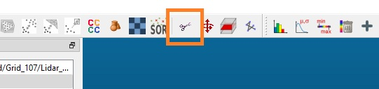
- Click on points just outside the embankment slope to create a polygon around the embankment.
- Once you've selected all points, right click on the mouse to stop and complete the polygon.
- **If needed, you can undo any point by pressing Alt + Left-click.
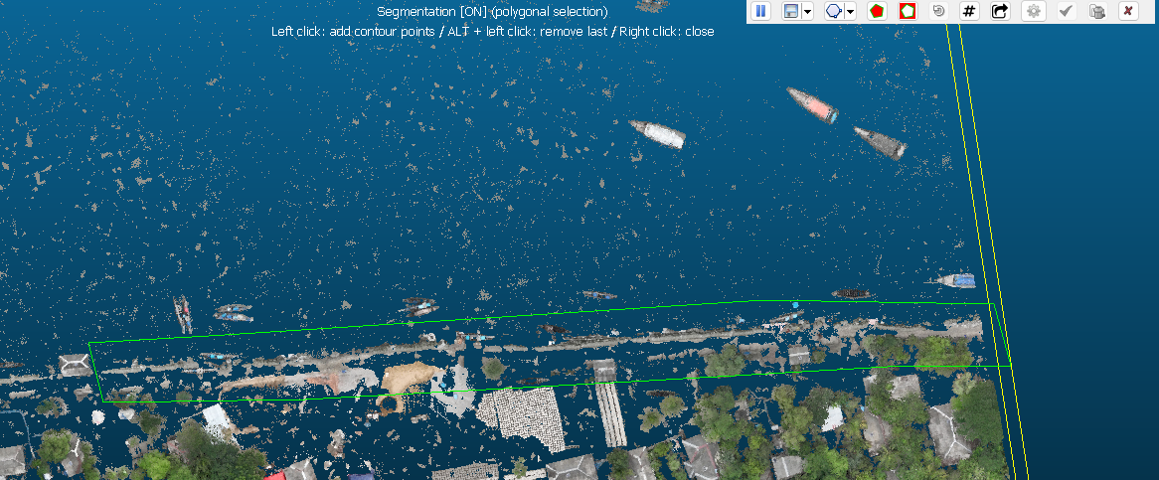
- A floating segmentation window appears in the upper-right corner, with two red buttons: “Segment In” and “Segment Out.”
- To keep the area inside the polygon you created, click “Segment In.” To exclude it, click “Segment Out.”
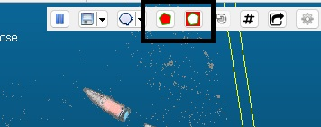

- Choose what to do in this case!
- When you click either "Segment In" or "Segment Out," segmentation will pause immediately. For now, click the checkmark (Confirm Segmentation).
- Two separate files will be created after segmentation. Keep only the newly created LAS file, as you'll be working on it to clean the embankment, removing non-soil points (you don’t need to delete the others).
- Click on the LAS file name (a yellow rectangle will appear around the image).
- Click the scissor icon again. To zoom in/out or adjust the image to avoid cutting embankment points while removing trees/other elements, use the “II” button to pause and unpause segmentation.
- Once the image is positioned comfortably (where no embankment points are cut), follow steps 13, 14, and 15.
- Do not confirm segmentation until all unnecessary points have been removed.
- Once cleaning is complete, confirm the segmentation. Two files will be created again. Keep the cleaned embankment file and delete the other.
- Finally, select the previous low points file and the newly cleaned file, then merge them by clicking “Merge Multiple Clouds.”

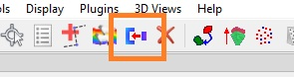
- Repeat the steps from 13 to 24 again and again until you have cleaned the whole embankment and merged with the lower points file.
- At last you will get an image with a clear view of the embankment.
- For saving the last cleared and merged file, select the file -> save -> save under the “Intermediate” folder (file type = .las).

Congratulations! You have completed the most minute and hectic part of the whole processing!

- Point cloud to Raster DEM generation

- Open the cleared las file in the Cloud Compare.
- Segment the completed las file like a rectangle or close to rectangle

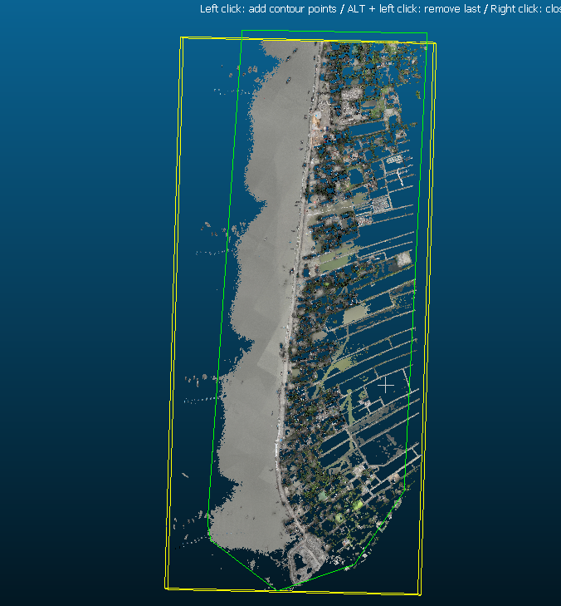

- Then click “convert a cloud to 2D raster”. The properties must be set as follows:

Grid:
Step = 0.5 (50 cm)
Active layer = cell height values

Projection:
Direction = z
Cell height = median

Empty cells:
Fill with = kriging

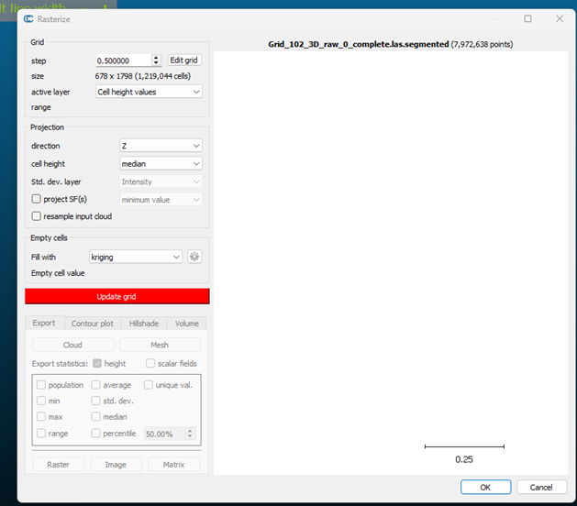

- Then click “update grid”.
- After the grid has been updated click on “Raster” on the same floating window (do not close the rasterize window yet).
- On the “Raster export options”, “Export heights” must be selected.

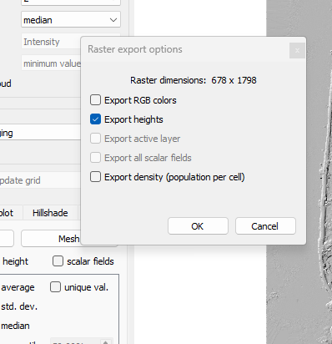
- Now, click ok and save the raster in the designated folder following the naming format (i.e., DEM_121).

- After that click on “Hillshade” and then “Generate”. This step is to check the embankment line.
- Then click ok and you are done here.
- Now open “Arcmap”.
- Click “Windows” and then "Catalog". Now, click the “Connect to folder” icon (if the folder is not connected) and connect the folder. Click the “Add Data” button, go to the connected folder, and add the raster file (DEM_121).
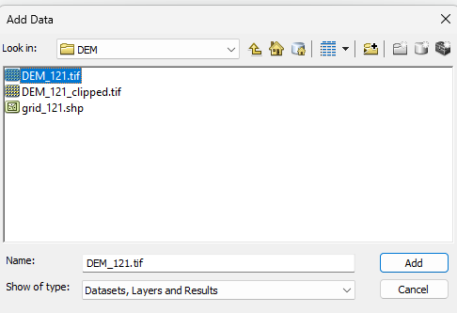

- Right click on the raster file and go to it’s “properties”. Check that in the source tab “Spatial Reference” is undefined. Go to ArcToolbox, then Data Management Tools, then Projection and Transformations, and finally double-click Define Projection. Choose “DEM_121” as the input dataset and notice that the coordinate system is unknown. Click the Coordinate System button , then expand Projected Coordinate Systems, and after that expand UTM, then WGS 1984, then Northern Hemisphere, and finally find and choose “WGS 1984 UTM Zone 45N”. Click OK twice and wait for a green tick to appear.
- In the Catalog window, right-click the relevant DEM folder, then create a new shapefile. Give a name (Drone_work) of preference, and the feature type must be “Polygon”. Edit the coordinate system to UTM zone 45N. Click ok to create the shapefile. Notice that the file has already been added to the layers.
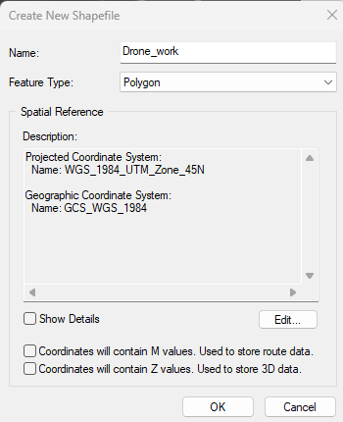
- Click Editor and then start editing. Zoom to the embankment side of the raster file, then draw a polygon feature as shown in the attached image. Keep in mind that the polygon is drawn by only keeping the embankment and the sideways land uses. Click Stop Editing and save the drawing.
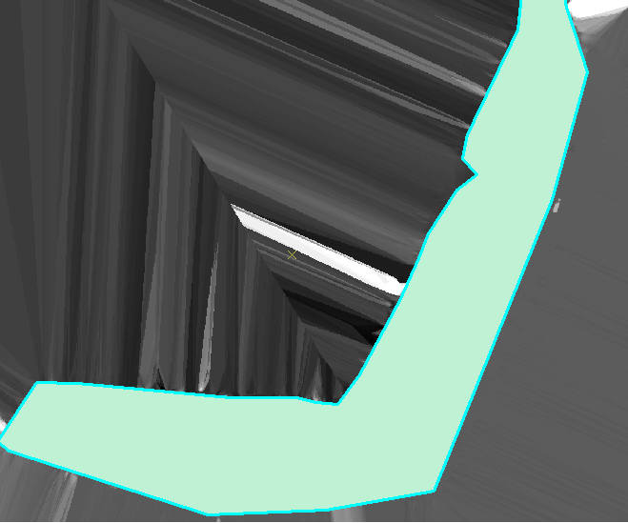
- Now we will keep only the raster area within the polygon boundary. To do that, we need to first create a file geodatabase. Go to the Catalog window. Locate and right-click in your folder, then NEW, then click "File Geodatabase". You can rename the file if you want. 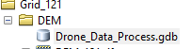
- Now go to ArcToolbox →Spatial Analyst Tools→Extraction →“Extract by Mask. Double-click to open the tool. Choose “DEM_121” as the input raster and the “Drone_work” file as the feature mask. For the output raster, browse to the newly created geodatabase, name it “Ex_Mask,” and click Save. Click ok to execute the action. Thus, your file will be created. Uncheck the “DEM_121” file to see the newly created file.
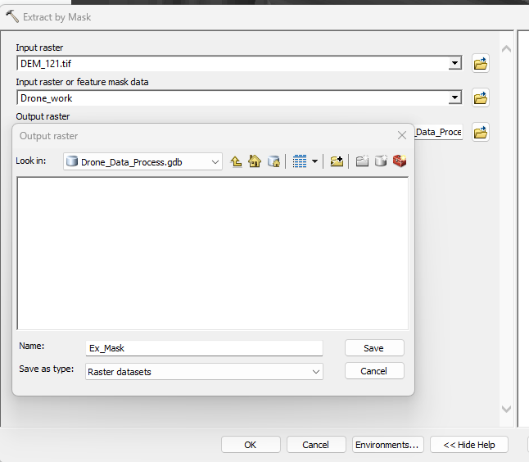
- Then export the masked raster file. Set “NoData as” = 0 (because the clipped or unwanted part of the raster will turn into black, which is not ideal for mapping or exporting maps).
- Select the relevant DEM folder as destination and change the name and save.

Optional,
- Search “Hillshade (Spatial Analyst)” tool. Input = newly clipped/ masked file.
- For better view drag the clipped raster file above the Hillshade file in the “Layers” area.
- Right click on the clipped raster file, go to “properties” -> “Display” -> Transparency = 70%. Op, change the color ramp if you must.

Step 3: Elevation correction to segmentation

ArcMap – correct elevation with SRTM DEM and ground-truth points using rstudio

Use the file “DEM_height_correction_manual.R”
#Process 1: Adjusting DEMs to SRTM height
#Process 2: Polygon creation for correcting individual DEM height with RTK points
#Process 3: Elevation correction with DEM
* Before process 4, move the uncorrected dem and the RTK corrected dems only to a new folder for the ease of understanding. In this case a new folder named “Correction with overlap” was generated.
#Process 4 (if necessary): Correct DEMs without RTK using overlapping RTK-corrected DEMs

B. ArcMap – embankment line and 100 m segmentation

- Open ArcMap. Click on the ArcMap icon to launch the software.
- Load the Necessary Datasets. You need to load all the clipped DEMs for the analysis. These DEM files will be used for creating the embankment centerline, but the corrected DEMs are not required at this stage.
- You need to create a new polyline shapefile to store the centerline you will draw.
- To create a shapefile:
  - In Catalog (the window on the right side of ArcMap), right-click on the folder where you want to save the shapefile.
  - Select New → Shapefile.
  - In the Create New Shapefile dialog:
    - For Feature Type, select Polyline.
    - Under Coordinate System, click on Edit to choose the correct projection (WGS 1984 UTM zone 45N) (add details if necessary)
  - Click OK to create the shapefile.
5. Draw the Centerline Through the Embankment: The goal here is to create a centerline that runs down the middle of the embankment.
  - Activate Editor by going to the Editor Toolbar. If it’s not visible, click on Customize → Toolbars → Editor.
  - In the Editor toolbar, click on Start Editing.
  - Choose the newly created polyline shapefile to start editing.
  - Use the Line tool to draw the centerline through the embankment. The line should follow the middle of the embankment and be drawn as accurately as possible.
  - Once you finish drawing the line, click Save Edits in the Editor toolbar and then click Stop Editing.
6. Split the Embankment Line into 100 m Segments:
  - In ArcToolbox, navigate to: Data Management → Features → Split Line at Distance.
  - In the Split Line at Distance tool:
    - Input Features: Select the embankment centerline.
    - Split Distance: Set this to 100 (meters).
    - Units: Choose Meters.
    - Output Feature Class: Name it embankment_100m_seg.
  - Click OK to run the tool.

Split the Line Again (If Necessary): Manual split is necessary when the line is too long. Our line is approx. 4224m long. Therefore, we need to split again. At first we divided our line by 844 to get 500m segments. Then again dividing into 5 segment to make each segment 100m length.

- Open the Attribute Table of the Embankment Segments: Right-click on the embankment_100m_seg layer in the Table of Contents and select Open Attribute Table.
- Go to Customize → Toolbars → Editor to show the Editor Toolbar.
- Click the Start Editing button (pencil icon) on the Editor toolbar.
- Choose the layer containing your embankment centerline shapefile as the editable layer.
- Click OK to start the editing session
- Right-click the embankment centerline layer in the Table of Contents and choose Open Attribute Table.
- In the Attribute Table, select the row (feature) that you want to split. You can click on the row to select it.
- On the Editor Toolbar, click the Editor menu (located at the top left of the toolbar).
- From the drop-down menu, select Split.
- A floating window will open. Select Into equal parts from the Split options. Write 5 (or any number you wish).

7. Add a Unique Segment ID (SEG_ID)
- In the Attribute Table of embankment_100m_seg, click on the Table Options button and select Add Field.
- Name the new field SEG_ID, and set the field type to Long Integer.
- Right-click the SEG_ID field in the attribute table and select Field Calculator.
- In the Field Calculator, input the following expression:
  - If the OBJECTID is ordered starting from 0, use:
SEG_ID = !OBJECTID!
  - If not, you can use:
SEG_ID = !OBJECTID! + 1
- Click OK to calculate and assign unique IDs to each segment.
8. Mosaic all the RTK_corrected DEMs in arcmap
  - Click on the Add Data button in the Standard toolbar (or click File → Add Data).
  - In the Add Data window, navigate to the folder where your RTK-corrected DEMs are stored.
  - Select all the RTK-corrected DEM files (those with the RTK_ prefix).
  - Click Add to load the DEMs into your map.
  - On the right side of ArcMap, you will see the ArcToolbox panel. If it’s not visible, click on the red toolbox icon to open it.
  - In ArcToolbox, go to:
Data Management Tools → Raster → Raster Processing → Mosaic To New Raster.
  - Click the folder icon next to Input Rasters.
  - In the Mosaic To New Raster window, select all the RTK-corrected DEMs you want to mosaic.
  - Hold Ctrl (or Shift to select multiple files) and select all the DEM rasters.
  - Click Add to add them to the Input Rasters box.
  - Click the folder icon next to Output Raster Dataset to choose where the output raster will be saved.
  - Choose a location on your disk or network and give the new mosaic raster a name (e.g., DEM_mosaic).
  - Make sure the file extension is .tif (e.g., DEM_mosaic.tif).
  - Set the Pixel Type based on your data. Most DEMs use 32-bit float to store elevation values.
  - For Elevation data, set Pixel Type to 32_BIT_FLOAT.
- Set the Cell Size parameter to Maximum of the input cell sizes. This ensures that the mosaicked raster will have the same resolution as the highest resolution input raster.
- Set the Number of Bands to 1, as you are working with single-band DEMs.
- In the Mosaic Method drop-down, choose LAST or BLEND, depending on how you want the overlapping areas to be handled.
  - LAST: The value from the last raster (in the input list) will be used if there is overlap.
  - BLEND: The overlapping areas will be blended, which might be useful for smooth transitions.
- Set NoData Value to 0 or a value that makes sense for your data. This is typically used to define areas with no valid data (e.g., if any DEMs don’t have data for certain regions).
- Once all parameters are set, click OK to run the Mosaic To New Raster tool.
- The tool will begin processing. A progress bar will appear in the Geoprocessing Results window.
- Wait for the tool to finish. The time it takes will depend on the number of rasters being mosaicked and the size of the DEMs.

Verify the Mosaic Output
- Once the tool has finished running, a new raster layer (e.g., RTK_mosaic) will appear in your Table of Contents in ArcMap.
- Click on the new raster to display it on the map.
- You can open the Attribute Table of the new mosaic raster (right-click the mosaic raster in the Table of Contents and select Open Attribute Table) to check for valid data and NoData values.
- Ensure the projection of the mosaicked DEM is the same as the input DEMs. If not, you can use Project Raster to change the projection.
Save the Mosaicked Raster:
- Right-click on the mosaicked DEM in the Table of Contents.
- Select Data → Export Data.
- In the Export Raster Data window, specify the output location and file name. You can choose to save it as GeoTIFF (.tif) or another format if needed.
- Click OK to save the raster.

9. Generate 1 Meter Points Along the Embankment
- To create points at 1-meter intervals along the embankment, use the Points Along Lines tool in ArcToolbox:
Cartography Tools → Data Driven Pages → Points Along Line.
- Set the Interval to 1 meter and ensure the Segment ID is included with each point.

10. Extract DEM Values to the 1 Meter Points
- To extract both DEM elevation values to the points, use the Extract Multi Values to Points tool:
ArcToolbox → Spatial Analyst Tools → Extraction → Extract Multi Values to Points.
- In the tool:
  - Input point features: Select the 1-meter points you generated.
  - Input rasters: Add the RTK_mosaic raster.
- Run the tool to extract elevation and slope values for each point.

C. Embankment lines for stat generation per segment

- Individual embankment lines

Draw four lines along the embankment. Two of them should be drawn at the end of the top layer and the end of the bottom layer of the riverside. They should be named Top_river, and Bottom_river. Simultaneously two top and bottom lines should be drawn on the landside of the embankment. The top lines will be used to calculate embankment width and the toe lines will be used with tops to calculate slope.

Create Top_river Line
- Open Catalog in ArcMap.
- Right-click the relevant project/DEM folder.
- Select New → Shapefile.
- Name the shapefile: Top_river.
- Set Feature Type to Polyline.
- Click Edit under the Coordinate System.
- Select the same coordinate system as the DEM, for example:
WGS 1984 UTM Zone 45N.
- Click OK.
Add Top_river.shp to ArcMap.
Start editing:
- Click Editor → Start Editing.
- Select Top_river as the editing layer.
- Open Create Features.
- Choose the Line Tool.
- Draw the line along the top edge of the embankment on the riverside.
- Double-click to finish the line.
- Click Editor → Save Edits.
- Click Editor → Stop Editing.

Create Toe_river Line
Repeat the same process.
- In Catalog, right-click the project/DEM folder.
- Select New → Shapefile.
- Name it: Toe_river.
- Set Feature Type to Polyline.
- Set the coordinate system to WGS 1984 UTM Zone 45N.
- Add it to ArcMap.
Then digitize:
- Click Editor → Start Editing.
- Select Bottom_river.
- Use the Line Tool.
- Draw the line along the bottom/toe of the embankment slope on the riverside.
- Double-click to finish.
- Save edits.
- Stop editing.
Repeat the same steps for creating Landside lines.

2. Create Cross-Section Shapefile

Draw cross section lines (vertical to the embankment line) at a distance of approx. within 10-40m. While drawing a line one should keep in mind the changes in emb. Width, height and any damaging features. Meaning the more discrepancy is noticed within the emb., the more lines we have to draw. All the cross sections must be long enough to cover the five lines we created until now.
- Open Catalog
- Right-click your working folder
- Select New → Shapefile
Set:
- Name: cross_sections
- Feature Type: Polyline
- Coordinate System: same as DEM (e.g., UTM Zone 45N)
✔ Click OK
✔ Add the shapefile to ArcMap
Start Editing and Prepare for Digitizing
- Open Editor Toolbar
- Click Start Editing
- Open Create Features
- Select cross_sections
- Choose Line Tool

🔹 General Rules
- Each line must be:
  - Perpendicular (≈90°) to the embankment
  - Extend from one side (land) to other side (river)
- Length should fully cross the embankment

🔹 Spacing Guidelines
- Maintain spacing of:
  - 5 m → 40 m
- Keep spacing:
  - Closer (5–20 m) in complex/damaged areas
  - Wider (30–40 m) in uniform sections

🔹 Where to Draw More Lines
Increase cross-section density where you observe:
- Changes in embankment width
- Variation in height/elevation
- Irregular slope conditions
- Signs of erosion, cracks, or damage
- Where there are turns in the emb. line
👉 Rule:
“More variation = more cross-sections”

Digitizing Process
For each cross-section:
- Click once on one side of embankment
- Draw line across embankment (keep it perpendicular)
- Double-click to finish
Repeat along the entire embankment. After going through it all:
- Click Editor → Save Edits
- Click Editor → Stop Editing

Assign Unique Cross-Section IDs
Add Attribute Field: Open Attribute Table
Add field:
- Name: Cross_no
- Type: Long Integer
- Click Ok.
- Right-click Cross_no → Field Calculator
Use Python:
autoIncrement()
Code block:
rec = 0
def autoIncrement():
global rec
rec += 1
return rec
✔ Apply → Each cross-section gets a unique no

3. Join embankment segment file to cross line file

a. Intersect Cross-Sections with Embankment Segments
- Open ArcToolbox
- Navigate to:
Analysis Tools → Overlay → Intersect
Set:
- Input Features:
  - cross_sections
  - embankment_100m_seg
- Output Type: Point
- Output Feature Class: emb_seg_cross_intersect
✔ Run tool
👉 Output: Points where each cross-section intersects a segment

b. Export Intersection Table to CSV

Option A: Direct Export
- Right-click emb_seg_cross_intersect
- Open Attribute Table
- Click Table Options → Export
- Save as .dbf or .csv

Option B (Recommended)
- Go to:
ArcToolbox → Conversion Tools → Table To Table
Set:
- Input Table → emb_seg_cross_intersect
- Output Location → folder
- Output Name → emb_seg_cross_intersect
✔ Run tool

c. Join Segment Info Back to Cross-Sections
👉 Purpose: Attach segment ID to each cross-section
- Right-click cross_sections
- Select Joins and Relates → Join
Set:
- Join Field (cross_sections) → cross_no
- Join Table → emb_seg_cross_intersect.csv
- Join Field (CSV) → cross_no
✔ Apply join

Export Joined Layer
- Right-click joined layer
- Select Data → Export Data
- Save as: cross_sections_joined
👉 Now each cross-section has segment ID

d. Intersect with Embankment Boundary Lines
Now intersect the updated cross-sections with each of the four lines separately:

Lines:
- Top_river
- Bottom_river
- Top_land
- Bottom_land

Example: Top_land Intersection
Repeat for each:
- Open Intersect Tool
- Input:
  - cross_sections_joined
  - one boundary line (e.g., Top_land)
- Output Type → Point
- Output Name → e.g., xs_top_land_pt
✔ Repeat for all four lines

e. Add X, Y Coordinates to Each Point File
For each point layer:
- Go to:
ArcToolbox → Data Management → Features → Add XY Coordinates
✔ Run
👉 This adds:
- POINT_X
- POINT_Y

f. Create Specific Coordinate Fields
For each file, create fields based on line type:

Example: Top_land
- Add fields:
  - top_land_x (Double)
  - top_land_y (Double)

Repeat for:
File | Fields
Top_land | top_land_x, top_land_y
Toe_land | toe_land_x, toe_land_y
Top_river | top_river_x, top_river_y
Toe_river | toe_river_x, toe_river_y

g. Populate Fields Using Field Calculator
- Right-click new field → Field Calculator
Set:
- top_land_x = POINT_X
- top_land_y = POINT_Y
Repeat for all files accordingly.

h. Export Each Attribute Table to CSV
Use:
- Right-click table → Export
OR
- Table To Table Tool
Save outputs:
- top_land.csv
- toe_land.csv
- top_river.csv
- toe_river.csv

✅ Final Output
You now have:
- 4 CSV files with precise coordinates
- Each linked to:
  - Cross-section_no
  - Segment ID
Now then, we will be using these four csv files generated from point files and the DEM_mosaic file to calculate embankment statistics such as height, width, land slope, river slope.

D. RStudio – elevation statistics per segment

Use the file “Segment_data_analysis_stat summary.R”

E. Final visualization

Project the segment_stats_full_final.csv file as shapefile and join with the 100m segment line using segment id. and export the attribute table as csv so that we know which stats are for which segment

1. Load the CSV File into ArcMap
- Click Add Data
- Select segment_stats_full_final.csv
- The CSV will appear as a table (not yet spatial)

2. Export Event Layer as Shapefile
- Right-click the new XY layer
- Select Data → Export Data
Set:
- Output location → project folder
- Output name → segment_stats_points.shp
✔ Click OK

3. Join with 100 m Segment Line
- Right-click embankment_100m_seg
- Select Joins and Relates → Join
Set:
- Field in embankment_100m_seg → Segment_ID (or Seg_No)
- Join Table → segment_stats_points.shp
- Field in join table → Segment_ID
✔ Click OK
👉 Now each segment contains corresponding statistics

4. Export Joined Layer
- Right-click the joined embankment_100m_seg
- Select Data → Export Data
Save as:
- embankment_segment_stats.shp
👉 This ensures the join is permanently stored

5. Export Final Attribute Table as CSV

Option A: Direct Export
- Open attribute table
- Click Table Options → Export
- Save as .dbf or .csv

Option B (Recommended)
- Go to:
ArcToolbox → Conversion Tools → Table To Table
Set:
- Input Table → embankment_segment_stats
- Output Location → folder
- Output Name → segment_stats_final.csv
✔ Run tool
# If there are too many columns that some of the columns become missing in the last shapefile then remove some unnecessary columns from the csv such as ID or so on and perform the Section E analysis once again from the start.

✅ Final Output
You will now have:
- A segment shapefile with all statistics attached
- A final CSV file linking:
  - Segment ID
  - Embankment height
  - Width
  - Land slope
  - River slope
  - And other summaries.

